Strategy Architecture Data - Report
  - Uni IT | Semester 1 McCusker Internship
April 2026

Table of Contents
1 Purpose 4
2 Areas Covered 4
3 Our Approach 4
4 Sharepoint Consolidation Project 5
4.1 Problem and Opportunity Statement 5
4.2 Current Environment 6
4.3 Approach Taken to Change Site 6
4.4 Future SharePoint Projection 6
4.5 Proposed Timeline 7
4.6 Risk and Challenges 7
4.7 Outcomes and Benefit 7
4.8 Recommendations & Next Steps 7
5 AI PoC 9
5.1 Problem and Opportunity Statement 9
5.2 Approach Taken 9
5.3 What we Built 10
5.4 Solution Overview 10
5.5 Risk and Challenges 10
5.6 Outcomes and Benefit 12
5.7 Recommendations & Next Steps 13
6 ESM and Integration Roadmap 16
6.1 Problem and Opportunity Statement 16
6.2 Current Environment 16
6.3 Approach Taken 17
6.4 Roadmap 17
6.5 Risk and Challenges 18
6.6 Outcomes and Benefit 19
6.7 Recommendations & Next Steps 19
7 Workato Roadmap 20
7.1 Problem Statement 20
7.2 Strategic Opportunity 20
7.3 Current Environment 20
7.3.1 Operational Process 20
7.3.2 IT Burden 20
7.3.3 User Experience 20
7.4 Approach Taken 20
7.5 Future Workato Vision 21
7.6 Zero-touch Flow 21
7.7 Risk and Challenges 22
7.8 Recommendations & Next Steps 22
8 Appendix 23
9 Afterthoughts 24
9.1 General Improvements and Recommendations 24

Purpose

Areas Covered

Our Approach
This internship encompasses three concurrent workstreams: SharePoint Revamp, Roadmap Creation, and AI Agent Usage Proof of Concept.
To manage delivery across all three, work was structured around context-switching between workstreams within each day where possible.
In practice however, progress was often dependent on access to platforms, materials, and stakeholders that were not immediately available.
For example, roadmap research was prioritised during periods where SharePoint or AI platform access had not yet been provisioned.
This led to a more opportunistic approach to scheduling, where workstream focus on any given day was determined by what was accessible and actionable at the time rather than a fixed rotation.

Sharepoint Consolidation Project

Problem and Opportunity Statement
The Strategy, Architecture & Data team currently operates two SharePoint sites running in parallel, a legacy Classic site and a partially built Modern site. Neither of which is fully active or well-known across UWA IT. Information is fragmented, outdated, and hard to find, meaning teams are making technology decisions without access to the architectural guidance they need. The DDC, which plays a critical governance role, is buried in a legacy platform that most people don't know exists.
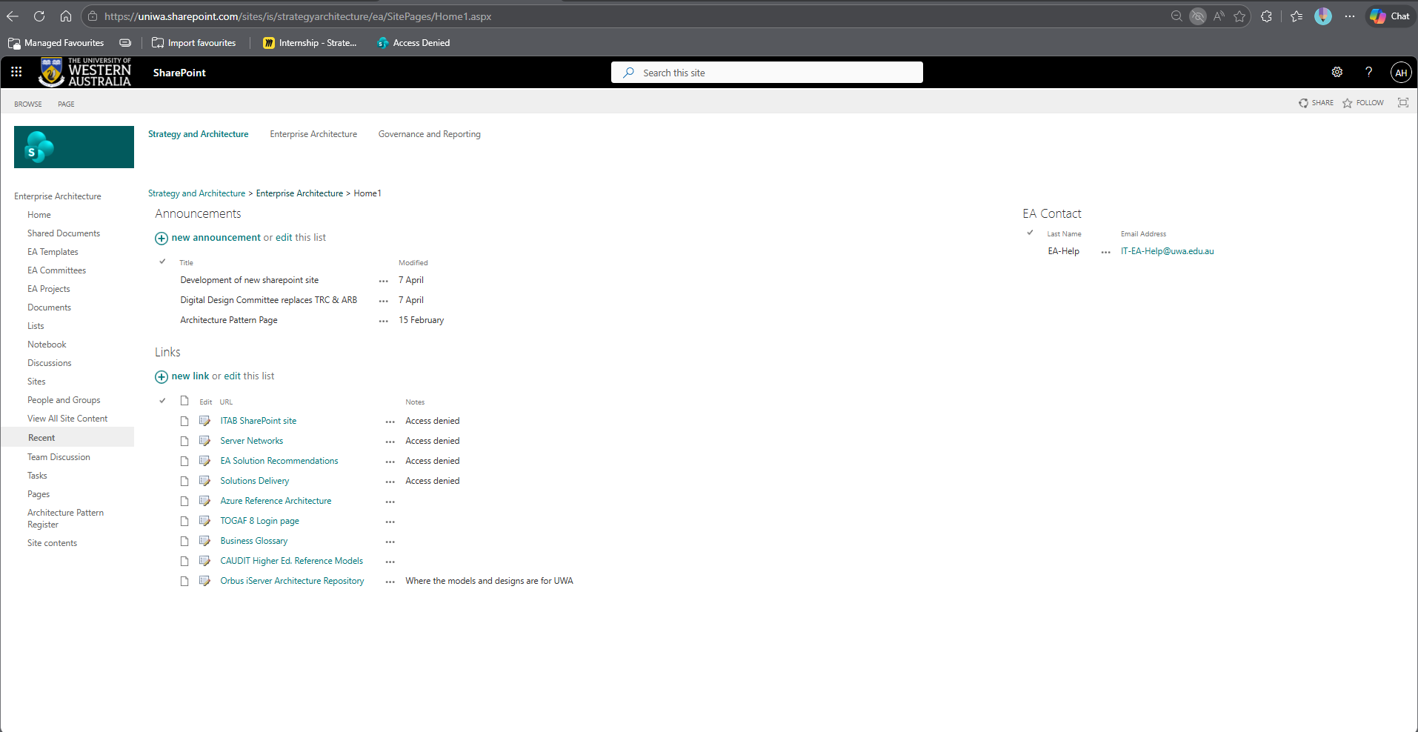
Figure 1 Classic sharepoint site (https://uniwa.sharepoint.com/sites/is/strategyarchitecture/ea)
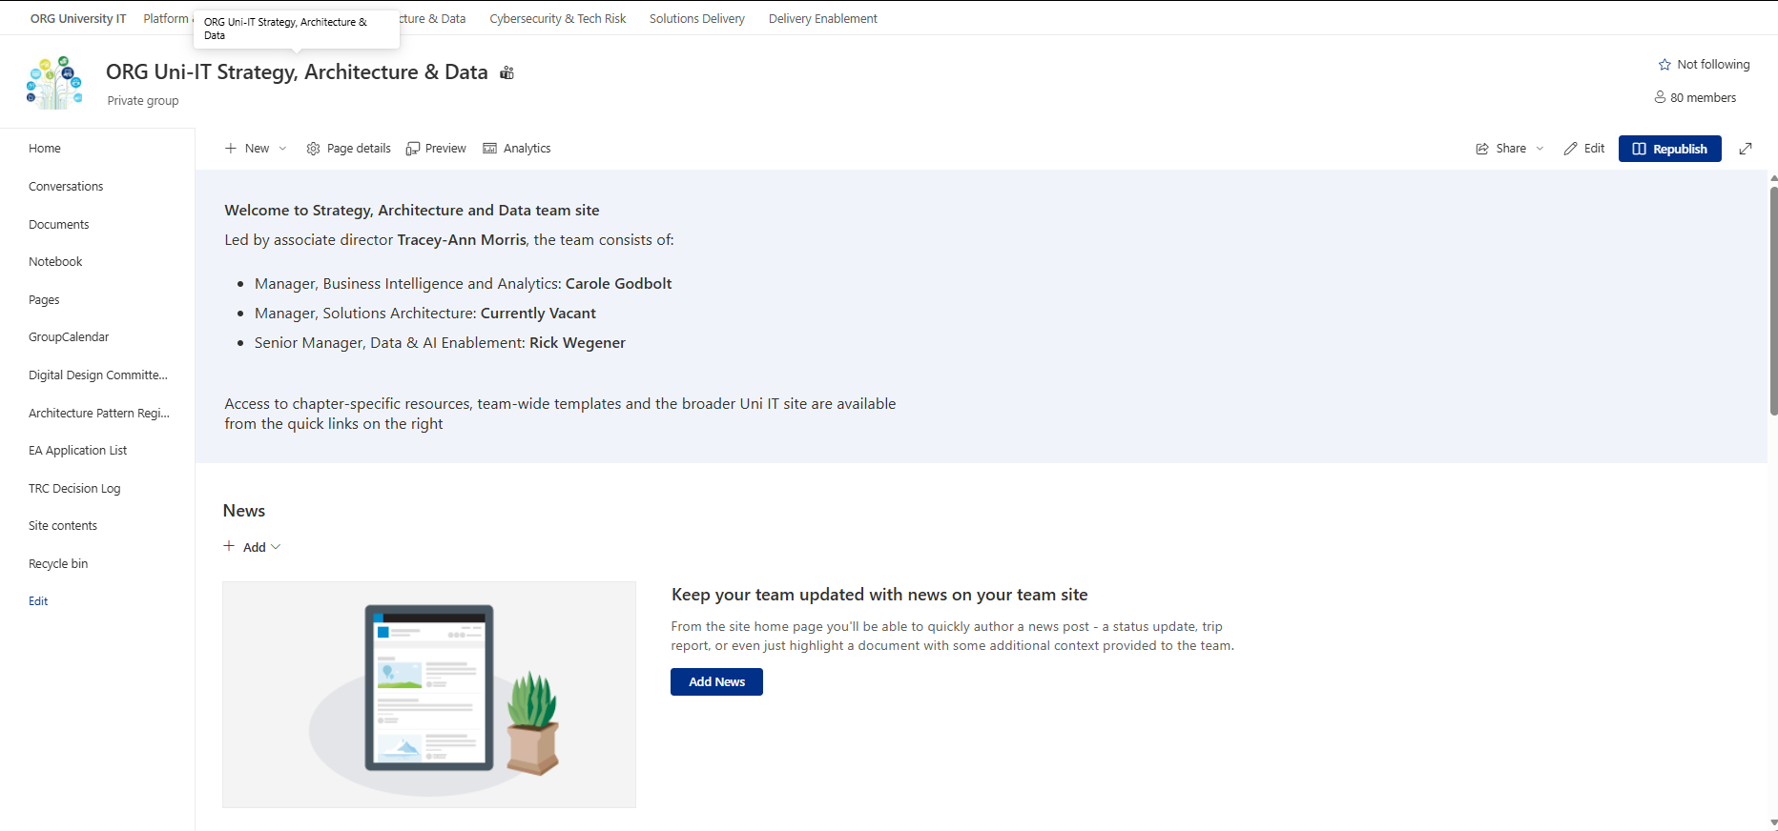
Figure 2 Modern sharepoint site (https://uniwa.sharepoint.com/sites/ORG-UNAZ22191C091/SitePages/Home.aspx)
The opportunity here goes beyond a simple tidy-up. Consolidating into a single, modern, maintained site gives the Architecture function a visible home. One that positions the team as a credible governance partner, makes DDC decisions discoverable and referenceable, and directly supports UWA's Southern Stars strategic direction, particularly the Smart Campus and Cyber Foundations objectives around establishing an architecture repository and design compliance.

Current Environment
The team maintains two SharePoint sites that serve overlapping but incomplete purposes. The Classic site runs on the legacy SharePoint platform and holds DDC work and historical content, however much of this content is stale or has been removed over time. The Modern site was built on the current SharePoint platform and contains the Business Analyst directory and some recent activity, but remains largely empty and underutilised with very low traffic.
A survey conducted ahead of this project confirmed that neither site is well known within the team or broader UWA IT. Homepage access rates on the Modern site were notably low, validating the low utilisation concern. The result is that no single source of truth exists for architecture governance, and the team's function and outputs are largely invisible to the people who need them.

Approach Taken to Change Site
The project followed a deliberate, staged approach to avoid disruption and prevent accidental data loss. It began with a short survey to assess current awareness and identify pain points before any changes were made. A sandbox test environment was then obtained to allow safe testing without touching the live site.
A content audit was conducted in coordination with Tracey to classify all existing content across both sites into three categories: keep, archive, or remove. Active content, starting with the DDC Approved Architecture List, was migrated from the Classic site to the Modern site. A staging version of the Modern site homepage was built and refined iteratively, and a workshop was planned to formally introduce the new site to the team and gather feedback before going live.
Workshop was done on 5th May to introduce the revamped site and collect feedback.

Future SharePoint Projection
The future state is a single, consolidated Modern SharePoint site that serves as the definitive home for the Strategy, Architecture & Data team. It will house the DDC Approved Architecture List, team information, and architecture governance resources in one accessible, well-structured location.
The site is designed to be maintainable and discoverable. It will be explicitly positioned as UWA's architecture repository in alignment with Southern Stars objective O36, supporting design compliance and continuous assessment across portfolios. Page analytics will be monitored post-launch to track engagement and validate the consolidation's impact.
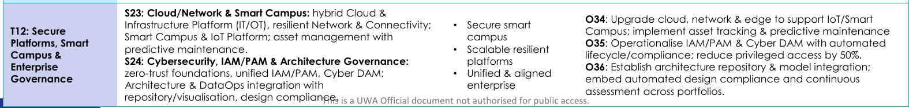

Proposed Timeline
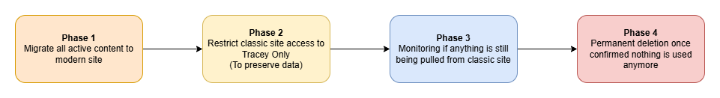
Currently we are already on Phase 2 with DDC register already being moved to the new modern site.

Risk and Challenges
- The primary risk in this project is accidental or premature data loss during the transition from the Classic site. The Classic site contains legacy content that, while largely inactive, may still be quietly referenced by individuals or processes that are not immediately visible. To manage this, a gradual sunset plan has been adopted rather than an immediate deletion approach.
- A secondary risk is adoption. The survey revealed that awareness of both sites is currently very low, which means launching a new consolidated site alone will not guarantee engagement. Without deliberate communication, workshops, and ongoing promotion, the new site risks falling into the same pattern of low utilisation.

Outcomes and Benefit
The content audit across both sites has been completed, with legacy data reviewed and categorised. The DDC Approved Architecture List has been successfully migrated to the Modern site. A staging homepage has been built and is ready for review. The Classic site sunset plan is established and underway, with access progressively being restricted to prevent accidental changes while monitoring continues.
Once the workshop is completed and the staging homepage goes live, the team will have a single, modern, consolidated site that genuinely functions as a source of truth for architecture governance at UWA IT. The Architecture function and DDC will be visible and accessible to the teams that rely on their guidance, and the foundation will be in place to grow the site into a full architecture repository as envisioned under Southern Stars.

Recommendations & Next Steps
The most immediate priority is awareness. The core problem was always discoverability, so regular workshops and targeted communications should be run to promote the site and help UWA IT understand the Architecture function and what it offers. This should begin with the planned launch workshop.
A clear content owner needs to be formally established with accountability for keeping the site current. Without this, the consolidation effort risks repeating the same cycle of neglect. The site should also be explicitly positioned as UWA's architecture repository in line with Southern Stars Smart Campus and Cyber Foundations, giving it strategic weight beyond an internal team page.
On the Classic site, the gradual sunset plan should continue by restricting access progressively and confirming with Tracey before any permanent deletion takes place. Finally, page analytics should be actively monitored following launch to validate whether the consolidation is driving the engagement and discoverability improvements it was designed to achieve.

Workshop Result
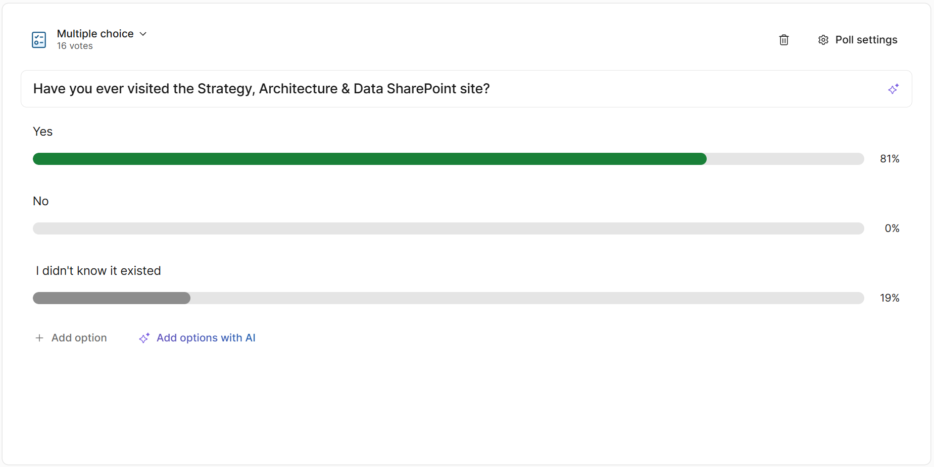
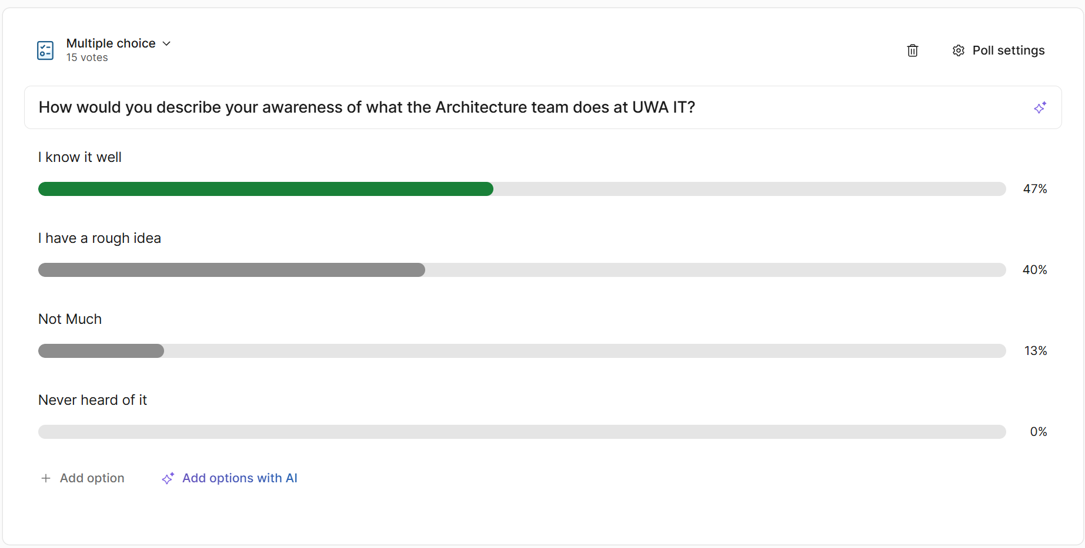
- Bruce suggested that the page (home page) should be visible for everyone in IT team, with only access control on certain sensitive page
- The [dummy url] pages are yet to be made and should be made
- There are suggestions that there should be another page for exact instructions to walk through the DDC processes
- There needs to be an entry point to access the page (solved by Ollie adding this tab to Uni IT intranet)
- Alan Mullet commented “I have a lot of sites bookmarked/attached via WebDAV. Is it possible to have a table of from/to?” this can be discussed further

AI PoC

Problem and Opportunity Statement
IT teams at UWA sit on a valuable but often underutilised source of institutional knowledge: their ServiceNow ticket history. Yet several obstacles prevent that knowledge from being effectively accessed.
ServiceNow’s limited search demands familiarity with its interface and keyword search punishes anyone who can't recall the precise terminology used in a past ticket, and when relevant information is scattered across multiple tickets, synthesising it into something actionable becomes a task by itself.
This results in compounding frictions: staff must invest time learning search workarounds and iterating on queries, issues that were solved in the past get re-submitted as if they were new, and requests that arrive underspecified trigger lengthy back-and-forth exchanges before resolution can even begin.
The opportunity is to replace that brittle, knowledge-dependent process with something smarter.
Contextual, semantic search powered by AI means any IT team member can describe a problem in their own words and surface what they need or summarise sprawling work notes to extract the exact next steps. Beyond search, this opens the door to AI-assisted ticket composition and self-service resolution, reducing load across teams and improving the experience for everyone raising issues. This PoC is the first step toward proving that pattern is viable on UWA IT infrastructure.

Approach Taken
The project started with a more ambitious vision. An AI companion for students with access to the LMS, class schedules, deadlines, and exam preparation support. That idea was quickly scoped down after identifying significant blockers: highly sensitive student identity and academic data, data governance concerns, and the reality that this team is running multiple workstreams simultaneously.
The decision was made to focus on a lower-risk PoC that still proves the core concept. ServiceNow ticket data from the BI team was selected as the data source. It is large enough to be meaningful, small enough to be manageable, and free of highly sensitive personal information. Azure Databricks was chosen as the platform to avoid reinventing the wheel. It offered a managed environment that worked within the team's time and bandwidth constraints, while still exposing API endpoints for future custom frontend development.
The data pipeline took raw ServiceNow tickets, ingested them into Spark, applied regex-based cleaning to strip HTML tags, email headers, footers, and signature lines, then reformatted the data into a structured JSON format for cleaner vector indexing. The result was a Vector Search index queryable by a language model rather than simple keyword matching.

What we Built
The output is an AI-powered Knowledge Assistant built on the Azure Databricks Knowledge Assistant Agent framework. It sits on top of a Vector Search index of BI team ServiceNow tickets and allows users to query that data using natural language rather than exact keywords.

Solution Overview
The assistant delivers three core capabilities.:
- Semantic ticket retrieval
Find a past ticket from a vague description ("help me find ticket about this weird firewall issue from years prior?")
- Ticket composition assistant
Suggests what information to include when lodging a new ticket, reducing bouncing between teams
- Self-service first-line support
Attempts to resolve based on historical data before a ticket is lodged
Together these three capabilities address the original friction point at multiple stages: finding past knowledge, creating better new requests, and resolving issues without human intervention where possible.

Risk and Challenges
There are several known limitations to be upfront about.
- The data pre-processing pipeline relies on regex-based cleaning, which works but is brittle. Aggressive pattern matching can occasionally strip out useful content, and it will not scale elegantly to more complex or varied data sources.
- The assistant currently lives entirely within the Databricks playground environment. There is no custom frontend, meaning it is not yet embedded anywhere a real user would naturally encounter it. Source citation in the interface is also limited, the original "View Source" experience only show plain URLs with little context, which has been partially addressed by switching to ticket number and title display, but this remains an area needing improvement.
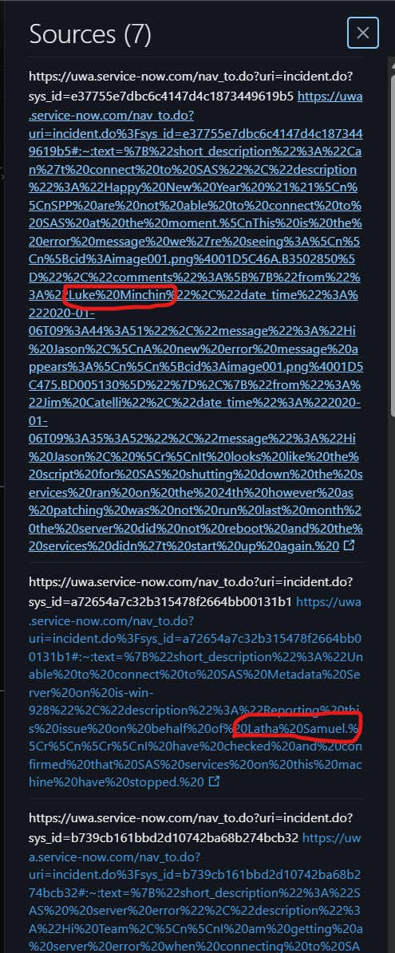
Figure 3 When URLs are passed, text highlighting html query (#:~:text) are automatically appended which can leak personal details
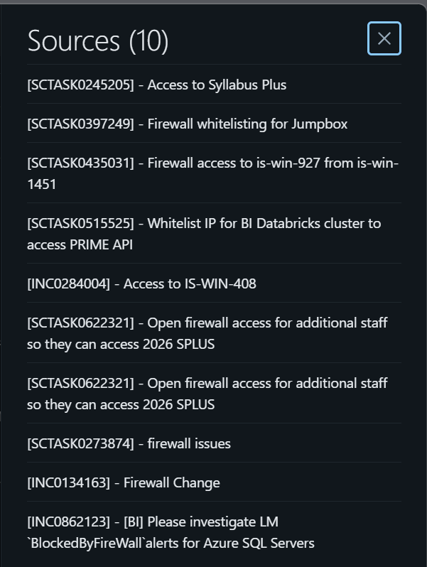
Figure 4 Current band-aid solution by attaching ticket number and title as source
- Model guardrails are basic at this stage. The system instructions work for typical queries but edge cases have not been fully accounted for. The current dataset is deliberately narrow. Expanding beyond BI tickets to other support domains would require a proper governance review before any ingestion of more sensitive data.
- Model sometimes are still affected by the randomness, meaning same question can still lead to different answers.
- A more significant architectural limitation was discovered during testing. Ticket number-based retrieval is unreliable within the current Knowledge Assistant Agent framework. When queried by exact ticket number, the vector search returned a similarity score of approximately 0.51 which is low even when filtering by the exact identifier. The root cause is that vector search is designed for semantic similarity, not structured exact-match lookups. The agent can only query against the text column we provide and has no capability to perform structured lookups outside of that. This means a user searching for a specific known ticket by its number will get inconsistent, hit-or-miss results. This behaviour was observed and confirmed through direct testing of the raw table, delta table, and vector search index. The data exists at every layer; the retrieval mechanism itself is the ceiling.

Outcomes and Benefit
The PoC successfully demonstrates that contextual AI search is feasible on UWA IT infrastructure using existing tooling. The core pattern—ingest, structure, index, query with a language model—has been proven end to end and is replicable. The assistant handles semantic queries, assists with ticket composition, and attempts self-service resolution, all functioning within the Databricks environment.
Beyond the immediate output, this work opens a genuine conversation about AI-assisted self-service across UWA IT more broadly. It also lays the groundwork for responsibly handling more sensitive datasets in future, having demonstrated what a governed, scoped approach to AI on institutional data looks like in practice.
Importantly, the PoC also produced a well-defined negative finding, which is equally valuable. Testing confirmed that ticket number-based retrieval is not reliable within the current Knowledge Assistant Agent architecture. This is not a data quality issue as the ticket exists and is correctly indexed but an architectural issue.
*Note:
Vector search finds approximately semantically similar content, not exact matches, making precise identifiers like ticket numbers an unreliable retrieval key without a complementary structured lookup mechanism. Discovering and documenting this ceiling is a genuine outcome of the PoC, and it directly informs what the next iteration needs to solve.

Recommendations & Next Steps
- The most impactful next step is building a custom frontend. The Databricks API endpoints are already exposed and ready. Custom frontend would enable integration as a SharePoint hub webpart or a UWA web component
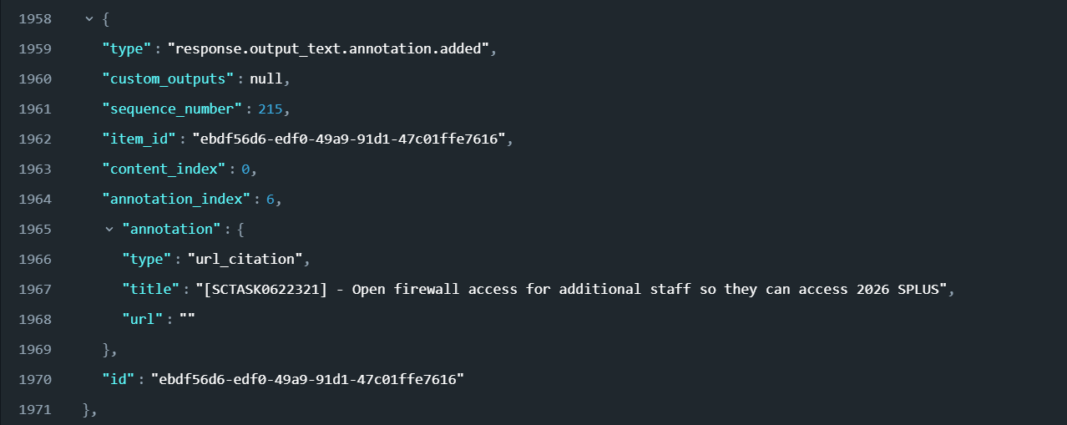
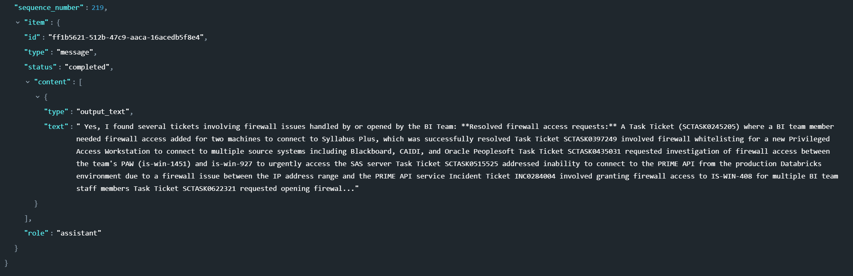
Figure 5 Databricks knowledge agent endpoint returns results in structured json format, making it possible to progress with custom frontend and address the Risk and Challenge point 2 about view source issue
- Data anonymisation should be addressed before any broader rollout. Implementing spaCy named entity recognition to strip personal names from ingested data before indexing would significantly reduce privacy risk and make the governance case for expansion much stronger. Reference on usage: https://www.geeksforgeeks.org/python/python-named-entity-recognition-ner-using-spacy/
- The pre-processing pipeline should be upgraded from regex to a more robust NLP approach to improve reliability and reduce the risk of useful content being stripped during cleaning. Model instructions and guardrails should also be tightened to handle edge cases more gracefully.
- Once the frontend and governance foundations are in place, it would be worth evaluating whether the assistant can be expanded beyond BI tickets to other support domains with a proper data governance review.
- On the ticket number retrieval problem specifically, there are a few potential paths forward with increasing complexity:
  - comments and work note threads could be chunked into individual rows with the ticket number retained as an identifier, keeping token sizes small and granular — though this would require meaningful rework of the current pipeline.
  - A middle path would be introducing a secondary structured data source that the agent can cross-reference using a ticket number obtained from an initial semantic query, effectively combining both retrieval approaches.
  - The longer term and most robust solution would be migrating to an agent framework that natively supports both semantic search and structured lookups, making number-based retrieval a reliable first-class capability rather than a workaround.
This PoC opens possibility for 2 more specialized projects that could be tackled:
  - Working on custom frontend or web component for the agent (needs Web Design skill set and possibly back end programming as middle man between the frontend and the azure data bricks knowledge assistant endpoint).
  - Working on the data processing and the information retrieval pipeline for the knowledge assistant model (needs Python programming skills)
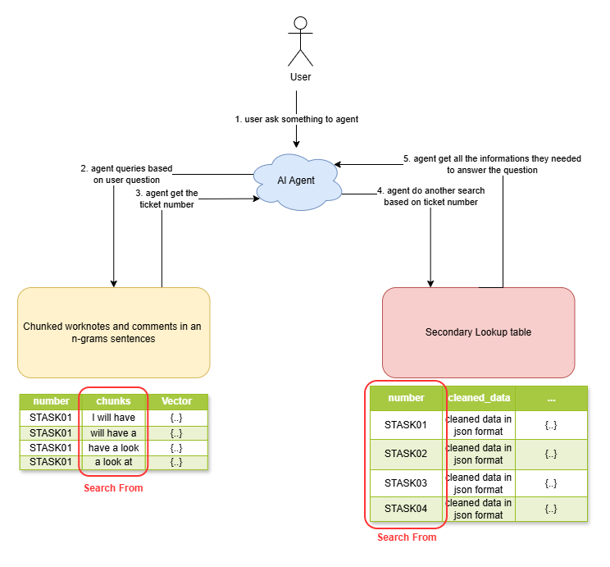
Figure 6 proposed solution illustration

ESM and Integration Roadmap

Problem and Opportunity Statement
UNI IT supports a broad and growing ecosystem of university systems, platforms, and services. As this ecosystem expands, the need to connect systems reliably, govern data flows consistently, and orchestrate work across platforms becomes increasingly critical to service quality and operational efficiency. Yet currently, UNI IT does not have a defined integration capability model, there is no shared strategy for how systems should connect, no agreed principles for platform selection, and no formal governance over what data moves between systems and how it is protected.
Integrations have been built incrementally over many years, largely driven by individual project needs rather than a coherent enterprise view. The result is a landscape that functions but is difficult to govern, difficult to change, and increasingly difficult to extend safely as data obligations and security expectations grow.
Compounding this, the full extent of UNI IT's current technology capability is not comprehensively documented or centrally visible. Platforms such as Databricks are understood to be in use, but the scope of their implementation, the integrations they participate in, and whether additional experimental or emerging capabilities exist alongside them is not fully known. This is itself a risk: it is not possible to govern, optimise, or make confident investment decisions about an integration landscape that has not been fully mapped.
From SD-ServiceNow-aPaaS-V1.0.3 document alone there are still some of the low/underutilized but licensed module. But without a full portfolio view we can't confidently assess what to maximise, what to drop, or what's already being built by another team. The "half-built jet" risk lives here as a current state observation.
The opportunity this roadmap addresses is to define integration as a managed capability within UNI IT. One that is intentional, governed, and grounded in a clear and complete picture of the technology that exists and to use the next three years to build and level up that state in a structured and prioritised way.

Current Environment
UNI IT's integration landscape currently centres on several key platforms. ServiceNow is the enterprise service management platform and system of record for IT operations, integrating with a wide range of systems including LDAP, Azure DevOps, Jamf, Microsoft SCCM, Cisco ISE, and Power BI. It is rated Cyber Criticality HIGH and Information Classification Highly Restricted. Azure (UAP) provides the cloud execution and identity layer, supporting automations such as MFA resets and VM provisioning triggered from ServiceNow. Databricks underpins the BI team's data platform, ingesting data from ServiceNow to support reporting via Power BI. Workato has recently been procured on a 3-year trial as an iPaaS capability, currently in very limited use with its role not yet formally defined.
This picture may be incomplete. The full technology catalogue including experimental tools or team-level capabilities has not been fully sighted. This is a gap this roadmap explicitly seeks to address. Once the technology catalogue exists, UNI IT can make responsible, evidence-based decisions about licence optimisation to maximising underutilised capabilities where there's a clear use case, and not renewing modules that genuinely aren't delivering value.
Several significant governance risks have already been identified. The recent Information Governance assessment of ServiceNow, the first comprehensive assessment the platform has ever undergone is rated the platform RED, with Major risks including personal data flowing from ServiceNow into Databricks and Power BI without de-identification, no formal record retention and disposal process, and no Information Classification Labels on tickets.
From a security perspective, the platform also has outstanding non-compliant items including no data-at-rest encryption, no column-level field encryption, and no SIEM integration for security event monitoring.
Additionally, as a government-affiliated institution, UWA requires that data be held within Australian data centres. This data sovereignty obligation applies to all platforms handling university data, including Workato. Discussions with Workato regarding data residency are currently ongoing and unresolved per our knowledge, which constrains how the platform can be used in the interim.

Approach Taken
This roadmap operates at the integration capability level above any individual platform and is intended to inform how UNI IT governs, designs, and evolves its integration practice over the next three years. Platform-specific roadmaps, including the Workato Integration Roadmap, sit downstream and are being developed separately.
This draft has been prepared with an incomplete view of UNI IT's full technology catalogue and should be validated with relevant stakeholders before being treated as final.

Roadmap
Phase 1 — Establish the Foundation (0–3 months)
Before a strategy can be built, UNI IT needs a clear picture of what technology it actually has. The first action is producing a technology capability catalogue mapping all platforms, tools, and integrations currently in use, including those in trial or at an experimental stage. This catalogue is the prerequisite for everything else in this roadmap and should be kept as part of enterprise architecture assets.
With that foundation in place, the phase moves to defining what integration and orchestration mean in the UNI IT context, and producing a concise integration strategy covering agreed principles, platform roles, data governance expectations, and decision criteria for new integration requests. A lightweight integration inventory that capture what connects to what, what data flows, and who owns each integration should be produced alongside this.
Resolving the Workato data residency question is also a Phase 1 action and should be treated as an active item requiring escalation.
Phase 2 — Govern and Remediate (3–9 months)
With the strategy and inventory in place, the focus shifts to governance and remediating known risks. This includes establishing standards for how integrations are designed and maintained across all platforms, and directly addressing the Major Governance findings. In particular de-identification of personal data in the ServiceNow to Databricks to Power BI flow, and establishing a formal record retention and disposal process.
Data governance obligations including data sovereignty, de-identification, and retention should be assessed consistently across all platforms in the catalogue, not just ServiceNow.
Phase 3 — Optimise and Extend (9 months–3 years)
With foundations in place, UNI IT can extend its integration capability with confidence, expanding Workato's role as the trial matures and data residency is confirmed, exploring event-driven integration patterns, and assessing more advanced ServiceNow capabilities such as AI Agents and Now Assist. A structured Workato trial review should also be conducted ahead of the renewal decision.
The technology catalogue should be reviewed and updated during this phase to capture any new capabilities adopted across the team.

Risk and Challenges
The incomplete visibility of UNI IT's technology landscape is the most foundational risk as any strategy built without a full picture may miss significant integrations or data flows. The technology catalogue directly mitigates this.
The unresolved Workato data residency question constrains the platform's use and puts the value of the 3-year trial at risk if left unresolved.
Without an agreed integration model, platforms will continue to be selected inconsistently, and duplication between ServiceNow Integration Hub, Workato, Azure, and Databricks will grow.
Producing a capability-level strategy also requires cross-functional engagement. For example, from the ServiceNow platform team, BI team, architecture, and management, and cannot be finalised in isolation. Resourcing to own and maintain the integration capability on an ongoing basis also needs to be considered.

Outcomes and Benefit
A technology capability catalogue gives UNI IT a clear shared view of what it has, enabling more confident planning and governance across the board.
A defined integration model reduces duplication, improves platform selection consistency, and makes it easier to extend or change the landscape safely.
Remediating the Information Governance and security findings reduces UWA's privacy and compliance exposure across all platforms not just ServiceNow.
A governed approach to Workato ensures the 3-year trial delivers strategic value and that the renewal decision is made on evidence rather than inertia.

Recommendations & Next Steps
Initiate the technology capability catalogue as the first concrete Phase 1 action, involving the ServiceNow platform team, BI team, and architecture and including license and capability review as formal output.
Confirm workstream scope and ownership with senior stakeholders before Phase 1 begins.
Escalate the Workato data residency question and contract as a priority, it is a prerequisite for defining Workato's role.
Coordinate with the Workato Integration Roadmap workstream to ensure consistency on platform roles and shared data governance obligations.
Treat the integration inventory and technology catalogue as living artifacts to be maintained and owned on an ongoing basis, preferably if reachable from the Sharepoint from earlier project.

Workato Roadmap

Problem Statement
- UWA's current IT landscape is burdened by a high volume of manual, repetitive execution tasks across siloed systems (ServiceNow, Entra/AD, Firewalls, SSL certificates).
- Automation demand from business units is outpacing IT capacity, creating critical bottlenecks and delaying time-to-value.

Strategic Opportunity
Transform UWA by empowering "Business Technologists" to build automations using low-code/no-code platforms. This reduces technical debt and simplifies complex integration barriers.

Current Environment

Operational Process
Heavily reliant on human effort, leading to delays, lack of consistency, and increased operational risks in the operational process.

IT Burden
Traditional integration approaches require heavy coding, causing automation projects to often be backlogged at the IT department.

User Experience
Business teams (e.g., Finance) deeply understand their processes but lack direct tools to improve them, leading to frustration regarding the resolution speed of the current system.

Approach Taken
Solution Positioning
Workato iPaaS has been selected as the core orchestration platform (3-year license secured).
Currently in Solution Architecture Stage 0/1 (Solution Reference & Design).
Phase 1: Foundations | Phase 2: Scale-out
Standardize Uni IT internal processes and establish core automation governance principles. | Enable the Citizen Developer model by deploying production automations for the Finance Group.

Future Workato Vision
- Operating Model: Operates as "Automation Factories" (e.g., Finance Automation Factory), centrally managed via a native workspace called Automation HQ (AHQ).
- Use Case Expansion: The Finance group will automate major cycles such as "Order to Cash" (syncing CRM and ERP) and "Procure to Pay" (invoice processing, reporting).
- Advanced Integration Technology:
  - Agentic AI & Copilot: Workato's AI assistant will help create documentation, design workflows (Recipe Copilot), and optimize the system.
  - Workbots: Bring automation directly into Slack or Microsoft Teams for rapid approvals.
  - Intelligent Document Processing (IDP): Automatically extract data from PDF invoices and images directly into the ERP system.
- The Core Vision: The three Workstreams do not operate as isolated "islands," but form a closed ecosystem:
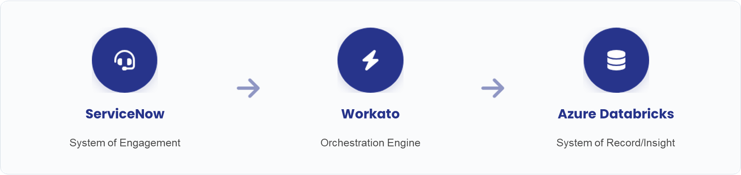

Zero-touch Flow
- Trigger
Users submit approval requests on the ServiceNow portal (WS2) (e.g., requesting Entra/AD permissions, firewall updates, SSL renewals).
- Action
Instead of manual IT execution, ServiceNow triggers Workato (WS3) via an A2A Publish/Subscribe (Webhook) integration pattern. Workato automatically runs the workflow to provision permissions on the target systems.
- Sync & Store
After provisioning is complete, Workato updates the status to "Completed" back in ServiceNow (WS2). Simultaneously, Workato sends all Audit Logs of this transaction to centralized storage at Databricks (WS1) to serve reporting and security compliance.

Risk and Challenges
- Shadow IT & Governance
Empowering business users (Citizen Developers) if uncontrolled can create rogue workflows. The solution is applying "Governed autonomy" via Automation HQ to limit resources and share secure connectors.
- Data Security
Workflows must follow privacy regulations and UWA's data classification models when accessing sensitive information.
- Training & OCM
Business specialists need time for training, support on Agile design thinking, and building habits to keep automated workflows instead of performing them manually.

Recommendations & Next Steps
- Align Use Case & Personnel: Stakeholders need to share and immediately select the first automation "Use case" for the Finance group, while nominating a list of potential Citizen Developers to begin participating.
- Confirm Phase 2 Schedule: Confirm the participation of the Finance Lead and lock in the official Kick-off plan for Phase 2.
- Configure Core Infrastructure: Uni IT needs to complete the installation of On-Premise Agents (OPA) and API Platform to be ready to connect Workato with on-campus servers (On-Premise Databases, ERP) before delegating rights to Citizen Developers.

Appendix
- Working One Note: https://uniwa.sharepoint.com/:o:/t/WRK-2025UniITSummerInterns/IgBhdaZ4l1MHQ4IrVeSDWIvvAdv7rWtQUVnB77DeZN67eDk?e=415IUN
- Service now work document: SD-ServiceNow-aPaaS-V1.0.3 (from Samuel Thomas)
- Servicenow Portfolio Management: https://www.servicenow.com/standard/resource-center/data-sheet/ds-application-portfolio-management.html

Afterthoughts

General Improvements and Recommendations
The following observation falls outside the scope of this internship but is noted here at the request of our supervisor, who invited us to reflect on broader improvement opportunities within University IT during our review session.
One practical example that illustrates the technology catalogue gap identified in this roadmap is the existence of a separate Moodle LMS server operated by the Department of Computer Science and Software Engineering (quiz.jinhong.org), running alongside UWA's official Blackboard LMS (lms.uwa.edu.au). This suggests that where the central platform does not fully meet a department's needs, teams may independently provision their own solutions outside of central IT visibility or governance.
This is worth flagging not as a criticism of any individual team, but as a concrete example of why a comprehensive technology capability catalogue matters. Shadow IT of this kind even when well-intentioned can create data governance blind spots, duplication of effort, and support complexity that central IT is not positioned to manage if it is unaware the platform exists. It also reinforces the case that the catalogue exercise recommended in this roadmap should extend beyond University IT's own known platforms to include a broader scan of what is operating across university departments.

